List
Secret messages
A list is used for storing data, just like a variable. However, a variable can store only one piece of data at a time in a named location, a list can store many.
Example: list players can store names of all players in a team
Send a secret message to your friend!
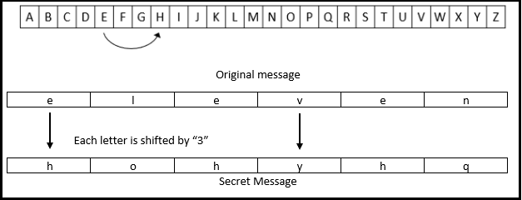
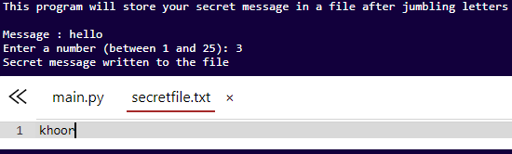
Get Ready
- Get project: Click on “Code” and then click save
Add Your Code
- Main Program: Ask player to enter message and set the key
message = input('Message : ')
key = 3
- Main Program: Encrypt each letter in the message by shifting 3 letters forward to make secret message
for char in message:
pos = alphabet.find(char)
newPos = (pos + key) % len(alphabet)
newChar = alphabet[newPos]
encMessage += newChar
- Main Program: Write secret message to the file
file.write(encMessage)
file.close()
print ('Secret message written to the file')
Try It Out!
- Click save and run your project. Can you decode your message?
- Write down encrypted words using different key lengths
Message | Key = 3 | Key = 7
Hello | khoor
run
jump
- Message to encrypt with key = 3:
The green ball will launch at noon tomorrow. Alert all teams!
____________________________________________________
Challenge!
Add numbers to your secret message
Update program to add numbers to the alphabet set
Change encryption key
Encrypt letter by shifting 5 letters forward
Custom encryption key
Ask player for the key to shift instead of using 5
key = int(input("Enter the key: "))
Bingo! – New Project
Generate a list of 10 random numbers (between 1 and 100) then ask player to guess a number then check if the players guess is in the list
Test Yourself
What will be screen color when this code is run?
from turtle import *
screen = Screen()
colors = ['red','blue','green', 'black']
screen.bgcolor(colors[2])
red
blue
green
black
Fun Fact!
Caesar cipher is a method of cryptography. To make a message secret with the Caesar cipher, each letter in the message is changed using a simple rule: change by three. A becomes D, B becomes E, and so on.
Roman military commander "Julius Caeser" used it to communicate with his army!

